Research on Multimodal Intelligent Recognition of InSAR Ground Deformation Clustering Areas Associated with Landslide Hazards A Case Study of Wudu District, Longnan City

line 1: 1st Given Name Surname
line 2: dept. name of organization
(of Affiliation)
line 3: name of organization
(of Affiliation)
line 4: City, Country
line 5: email address or ORCID
line 1: 4th Given Name Surname
line 2: dept. name of organization
(of Affiliation)
line 3: name of organization
(of Affiliation)
line 4: City, Country
line 5: email address or ORCID
line 1: 2nd Given Name Surname
line 2: dept. name of organization
(of Affiliation)
line 3: name of organization
(of Affiliation)
line 4: City, Country
line 5: email address or ORCID
line 1: 5th Given Name Surname
line 2: dept. name of organization
(of Affiliation)
line 3: name of organization
(of Affiliation)
line 4: City, Country
line 5: email address or ORCID
line 1: 3rd Given Name Surname
line 2: dept. name of organization
(of Affiliation)
line 3: name of organization
(of Affiliation)
line 4: City, Country
line 5: email address or ORCID
line 1: 6th Given Name Surname
line 2: dept. name of organization
(of Affiliation)
line 3: name of organization
(of Affiliation)
line 4: City, Country
line 5: email address or ORCID

Abstract—The Wudu District of Longnan City, located in the West Qinling Mountains, is frequently affected by landslide disasters. Conventional InSAR deformation interpretation struggles to rapidly identify ground deformation clustering areas associated with potential landslide hazards. Based on Sentinel-1A satellite data, this study adopted Stacking InSAR to obtain ground deformation phases. Combined with multi-source remote sensing data, a multimodal sample set was constructed. The MSegFormer lightweight Transformer model was then used to intelligently identify landslide-related deformation clustering areas. The results show that 20 landslide-related deformation areas were identified from the ascending data and 71 from the descending data. The proposed method effectively suppresses noise and distinguishes landslide deformation from human-induced engineering disturbances. The overall F1 score of the model reached 80.89%, outperforming DeepLabV3+ and Attention UNet. This study demonstrates that the multimodal intelligent recognition method has good practical value in detecting potential geohazards in Wudu District, Longnan City.
Keywords—InSAR; ground deformation clustering areas; landslide hazards; multimodal remote sensing; MSegFormer; Wudu District

Introduction
Wudu District, Longnan City, is situated in the western section of the West Qinling Orogenic Belt, where intense neotectonic movements, deeply incised river valleys and fragmented rock masses are widely developed. As a result, this area ranks among the most severely landslide- and debris-flow-prone regions in China^{[1]}. Manual interpretation of potential landslide hazards by identifying InSAR-derived surface deformation clusters suffers from low efficiency and strong subjectivity, which can hardly satisfy the requirements for rapid and large-scale mapping of surface deformation zones associated with potential landslides. Therefore, the intelligent identification of InSAR surface deformation clusters related to potential landslide hazards using multi-source remote sensing and deep learning is of great practical significance for improving the efficiency of landslide hazard detection.
Stacking-InSAR technology can effectively mitigate atmospheric delays and noise to retrieve regional surface deformation velocities, serving as a timely and important tool for potential landslide identification^{[2].} In recent years, deep learning has achieved remarkable progress in semantic segmentation of remote sensing imagery^{[3].} Convolutional neural networks (CNNs) have been applied to landslide hazard recognition^{[4]}; however, their inherent locality constrains the ability to capture contextual information. To address this limitation, attention mechanisms have been introduced to extract global feature information^{[5]}. Vision Transformer (ViT) overcomes the drawbacks of CNNs by establishing global feature correlations and preserving spatial topological information via positional encoding[^{6]}, yet it suffers from high computational complexity. The MSegFormer framework enables efficient multi-scale feature fusion, adapts to both local details and global contextual information, and is well compatible with dense prediction tasks^{[7]}. At present, studies integrating deep learning with InSAR deformation phases for potential landslide identification remain limited, mainly plagued by problems such as non-standard sample labeling, simplistic multi-modal fusion strategies, and high model sensitivity to noise.
In summary, in response to the practical demands of landslide hazard identification in Wudu District, Longnan City, this study employs Stacking-InSAR to obtain surface deformation velocities. A 10-band multi-modal dataset is constructed by integrating multi-source data including optical images, DEM, slope, terrain relief and snow-ice coverage. The MSegFormer model is utilized to achieve pixel-level identification and classification of deformation clusters associated with landslides. Its accuracy is further compared with those of U-Net, DeepLabV3+ and Attention U-Net to verify the effectiveness and robustness of the proposed method. This work is expected to provide a technical reference for the intelligent identification of geological disaster hazards in complex mountainous areas.

Study Area and Data

Study Area Overview
Wudu District is located in the southeastern part of Gansu Province, with an elevation ranging from 660 to 3600 m. The terrain is high in the northwest and low in the southeast, characterized by steep mountains and intensely incised gullies. The climate is a humid subtropical monsoon climate in the northern subtropical zone, with an annual precipitation of 400–800 mm and concentrated rainstorms. The geological structure is complex, as the district lies at the junction of three major tectonic units in the western segment of the Qinling Orogenic Belt. Fractured rock masses and widespread weak strata, combined with human engineering activities such as slope cutting for construction and road building, have resulted in frequent occurrences of landslides and debris flows.

Data Sources and Preprocessing
In this study, Sentinel-1A SAR images from 2021 to 2023, GF-1/GF-2 multispectral imagery, and ALOS World 3D DEM data were employed. All data were unified to the WGS-84 coordinate system and resampled to 10 m resolution. The average annual surface deformation velocity was obtained using the Stacking InSAR technique. A 9-band multi-modal dataset was constructed, including ascending/descending InSAR deformation phases (3 bands), RGB optical imagery (3 bands), elevation, slope, and terrain relief.

Methodology
Surface deformation phases were obtained using Stacking-InSAR and fused with multi-source remote sensing data. Under a three-dimensional visualization environment, visual interpretation was conducted to construct a pixel-level sample set consisting of three categories: landslide-related deformation, non-landslide deformation, and non-deformation regions. Subsequently, standard HDF5 format datasets were generated through positive–negative sample balancing, data augmentation, and stratified sampling. Finally, a multi-modal intelligent recognition model based on MSegFormer was established and trained with 10-band data as input. The proposed model was applied to intelligent recognition in Wudu District, Longnan City, and its accuracy was compared with that of DeepLabV3+, UNet, and Attention UNet.

Stacking Technique
The Stacking technique combines multiple interferograms to address the problems of interferometric decorrelation and atmospheric delay inherent in conventional InSAR, thereby enabling the estimation of regional surface deformation velocities. As one of the most fundamental algorithms for multi-temporal InSAR, Stacking estimates the linear phase rate using multiple unwrapped differential interferograms. This process essentially constitutes a linear regression of N groups of observations based on the least squares method, with the estimation formula expressed as follows:
式中：为干涉图的时间基线；为解缠的差分干涉相位；为线性相位速率。

Units
MSegFormer is a lightweight Transformer-based semantic segmentation model. It was proposed to address the limitations of Vision Transformer (ViT) in prediction tasks, including fixed feature resolution, positional encoding interpolation errors, excessive computational complexity, and difficulty in directly fusing multi-source data. Based on the SegFormer architecture, MSegFormer is adapted and reconstructed for multi-channel inputs including multi-temporal InSAR deformation phases, multispectral images, and DEM data. The model mainly consists of three components: overlapping patch embedding, a hierarchical Transformer encoder, and a lightweight all-MLP decoder.
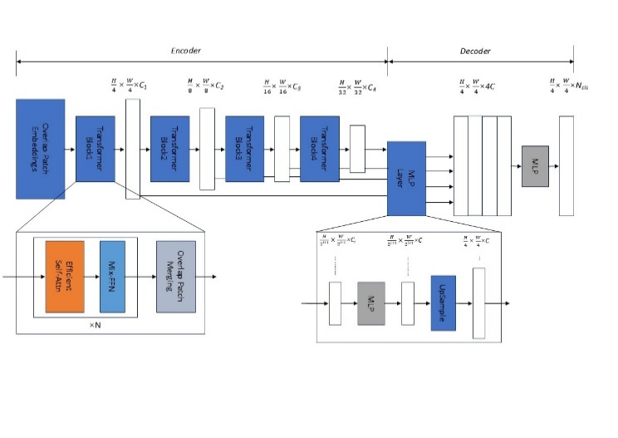
- Architecture of the MSegFormer model

Overlap Patch Embeddings
MSegFormer adopts overlapping patch merging, and constructs a hierarchical feature structure using convolutional layers (kernel = 7, stride = 4, padding = 3) and LayerNorm. The overlap between adjacent patches preserves local spatial continuity and enlarges the receptive field.

Overlap Patch Embeddings
The hierarchical Transformer encoder serves as the core component of MSegFormer. First, the first-stage embedding layer is reconstructed by dynamically instantiating nn.Conv2d and setting the number of input channels in_channels as a configurable parameter, thereby supporting multi-source data with arbitrary channel numbers. The encoder then consists of four consecutive Transformer blocks (Block1 to Block4), each outputting feature maps at different resolutions. In addition, the feed-forward network within the encoder adopts a Mixed Feed-Forward Network (Mix-FFN), which integrates convolutional and linear feed-forward structures on the basis of the traditional Feed-Forward Network (FFN):
$x_{out}=MLP\left(GELU\left({Conv}_{3×3}\left(MLP\left(x_{in}\right)\right)\right)\right)+x_{in }$
where $x_{in }$​ denotes the features derived from the self-attention module. By introducing a convolutional structure, Mix-FFN enables the model to further capture spatial information. This design enhances spatial feature modeling while maintaining a global receptive field.

Lightweight All-MLP Decoder
MSegFormer employs a lightweight decoder composed exclusively of MLP layers. Multi-level features from the encoder are first unified in channel dimension via an MLP layer. These features are then upsampled to 1/4 resolution, concatenated, and fused using another MLP layer. Finally, the fused features are fed into a subsequent MLP layer to predict the segmentation mask with a resolution of H×W×C, where C denotes the number of object categories.

Precision Evaluation Indicators
Precision, Recall, F1-Score, and mean Intersection over Union (mIoU) are adopted as the evaluation indicators to assess the performance of the segmentation model. For a single category, True Positives (TP) refer to the pixels that are correctly identified and classified, False Positives (FP) represent the pixels that are incorrectly recognized as the target category, and False Negatives (FN) denote the pixels of the target category that are missed and not identified.
The final precision is evaluated by the macro-average of F1-Scores of three categories, namely landslide-related deformation, non-landslide-related deformation, and non-deformation. The calculation formula of the macro-average F1-Score is defined as follows:
$\text{Macro F1}=\frac{{F1}_{0}+{F1}_{1}+{F1}_{2}}{3}$​ （3）

Results and Analysis

Comparison of Model Performance
On the test set of Wudu District, the proposed MSegFormer is compared with DeepLabV3+, UNet, and Attention UNet. All models adopt the same 10-band multimodal input and training strategy. The quantitative results are presented in Table 1.
- Comparison of Precision for Intelligent Recognition of Multimodal InSAR Deformation in Wudu District
10-Band | Precision | Recall | mIoU | F1-Score
DeepLabV3+ | 76.89 | 56.42 | 52.60 | 20.21
UNet | 33.20 | 33.36 | 33.26 | 33.37
Attention UNet | 84.61 | 70.93 | 64.88 | 76.08
MSegFormer | 86.35 | 76.64 | 70.28 | 80.89
SegFormer achieves an F1-score 4.81 percentage points higher and an mIoU 5.4 percentage points higher than Attention UNet, with Precision and Recall reaching 86.35% and 76.64%, respectively. This indicates that the proposed method can better balance precision and recall. UNet exhibits the poorest performance, showing weak capability in capturing the complex spatial information of InSAR deformation. Although DeepLabV3+ yields relatively high precision, it suffers from low recall and severe missed detections. Benefiting from global self-attention and multi-scale feature representation, MSegFormer achieves the optimal overall performance.

Identification Results of Deformation Concentration Zones in Wudu District
The MSegFormer model is applied to identify deformation zones in Wudu District, and the results are illustrated in Fig. 2. A total of 71 deformation concentration zones are identified from descending orbit data, among which 69 are landslide-related deformations and 2 are non-landslide deformations induced by engineering activities. For ascending orbit data, 20 deformation zones are detected, all of which are landslide-related. The deformation anomalies are generally distributed in dense belts in the northwest of the urban area, extending southeastward along the Bailong River, which is highly correlated with regional geological structures and fluvial erosion. The number of deformations identified by the descending orbit is larger than that by the ascending orbit, indicating that the main deformation direction in this region is more consistent with the line-of-sight direction of the descending orbit, which demonstrates the necessity of multi-orbit InSAR observations.
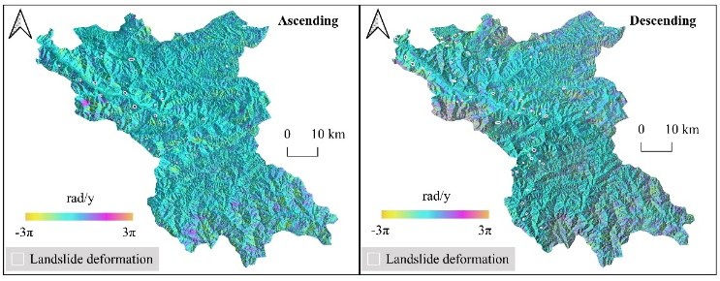
- Identification results of ascending and descending orbits in Wudu District
- Landslide-Related Deformation Identification:Figure 3 presents two typical landslide cases. Case 1 is located on a gentle slope on the left bank of the Bailong River, where the InSAR deformation phase exhibits a typical concentrated deformation pattern. Optical images reveal farmland reconstructed from an ancient landslide with dense villages, which is consistent with existing survey results. Case 2 is situated on the deeply incised mountain sidewall on the right bank of the Bailong River in western Wudu District, with obvious deformation characteristics and clear landslide boundaries in optical images. Although the InSAR deformation is subject to strong noise interference, the proposed method shows outstanding performance in noise suppression and accurately identifies the deforming landslide in this region, satisfying the application requirements of wide-area intelligent identification.
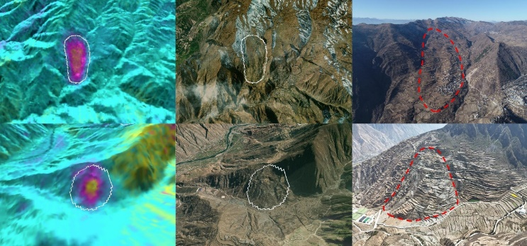
- Multi-source remote sensing cross-validation of two typical deformation targets ((Upper) Case 1: Ascending InSAR + Optical + UAV panorama; (Lower) Case 2: Descending InSAR + Optical + UAV panorama)
- Discrimination ability for non-landslide deformations:Two non-landslide-related deformations are identified by the model from descending orbit data. Verified by optical imagery, both are located at construction sites in the urban area with flat terrain, and the deformations show a local funnel-shaped pattern, which is significantly different from the slope deformation mode of landslides. This indicates that MSegFormer can effectively use topographic and optical features to distinguish deformations caused by human engineering activities from landslide deformations.
- Noise suppression and dense target identification:The descending orbit data over Wudu District are strongly affected by noise, posing great difficulties for traditional manual interpretation. Relying on global self-attention and hierarchical feature fusion, MSegFormer suppresses noise while successfully identifying densely distributed deformation targets, such as multiple deformation zones on deeply incised mountain flanks in mountainous areas, some of which contain residential settlements and were unrecorded in previous surveys. The efficient noise suppression capability of the model provides support for the rapid screening of wide-area geological disaster hazards.

Discussion
This study integrates InSAR deformation phase and multi-source remote sensing data, and employs the MSegFormer model to realize intelligent identification of deformation concentration zones associated with potential landslide hazards. The results demonstrate that multi-modal data (topography, optical imagery, etc.) are crucial for distinguishing landslide deformations from anthropogenic engineering disturbances, and relying solely on InSAR tends to cause misjudgment. The proposed MSegFormer achieves an F1-score of 80.89%, outperforming DeepLabV3+ and Attention UNet. Benefiting from the global self-attention mechanism and multi-scale feature extraction capability of Transformer, the model can effectively capture irregular deformation boundaries and maintain robustness under strong noise conditions. The discrepancy in the number of identified deformations between ascending and descending orbits (71 from descending orbit and 20 from ascending orbit) reflects that the dominant deformation direction in the study area is more consistent with the line-of-sight direction of the descending orbit, verifying the necessity of multi-orbit observations. The model successfully identifies numerous weak deformation signals and previously unrecorded deformation zones, exhibiting favorable noise suppression and preliminary screening performance. Limitations of this work include subjectivity in sample labeling, spatial scale mismatch among multi-source data, and the lack of consideration for non-linear deformations. Future work will expand the cross-regional sample database and introduce time-series InSAR features to improve the generalization and practicality of the model.

Conclusion
Taking Wudu District of Longnan City as a typical demonstration area, this study obtains surface deformation phase based on Stacking InSAR, constructs a 10-band multimodal dataset by fusing multi-source remote sensing data, and adopts the lightweight Transformer model MSegFormer to intelligently identify InSAR surface deformation concentration zones associated with potential landslide hazards. On the test set of Wudu District, MSegFormer achieves an F1-score of 80.89% and an mIoU of 70.28%, outperforming DeepLabV3+, UNet and Attention UNet, which verifies the superiority of the Transformer architecture in multi-source remote sensing data fusion and landslide deformation recognition. The model is applied to identify 20 landslide-related deformations from ascending orbit data and 71 from descending orbit data, and can effectively distinguish landslide deformations from anthropogenic engineering disturbance deformations, demonstrating its practical value in detecting geological disaster hazards in complex mountainous areas. With favorable transferability and operational potential, the proposed method can provide technical support for the regular hazard identification, monitoring and early warning in landslide-prone regions of the West Qinling Mountains.

Acknowledgment
This work was supported by the 2023 Ministry-Province Cooperation Pilot Project of the Ministry of Natural Resources (No. 2023ZRBSHZ051), entitled “Key Technologies for Comprehensive Remote Sensing Identification and Application of Geological Disaster Hazards in Gansu Province”, the Science and Technology Innovation Project of the Gansu Provincial Department of Natural Resources (No. 202431), and the Gansu Provincial Youth Science and Technology Fund Program (Grant Nos. 24JRRA683 and 26JRRA464). The authors are grateful to the European Space Agency (ESA) for providing Sentinel-1A data, and to the China High-Resolution Earth Observation System for supporting GF-1/GF-2 optical remote sensing data. We also thank Dr. He Peng from the China Aero Geophysical Survey and Remote Sensing Center for Natural Resources for his support and assistance. Special thanks go to the anonymous reviewers for their valuable comments and suggestions to improve the quality of this paper.

References
- T. Qi, X. Meng, Y. Zhao, X. Su, G. Chen, R. Zeng, Y. Zhang, Y. Li, and D. Yue, “Formation and distribution of landslides controlled by thrust-strike-slip fault zones and fluvial erosion in the Western Qinling Mountains, China,” Engineering Geology, vol. 323, p. 107209, 2023.
- Y. Xu, T. Li, X. Tang, X. Zhang, H. Fan, and Y. Wang, “Research on the applicability of DInSAR, stacking-InSAR and SBAS-InSAR for mining region subsidence detection in the Datong coalfield,” Remote Sensing, vol. 14, p. 3314, 2022.
- T. Hoeser and C. Kuenzer, “Object detection and image segmentation with deep learning on Earth observation data: A review—Part I: Evolution and recent trends,” Remote Sensing, vol. 12, p. 1667, 2020.
- O. Ghorbanzadeh, H. Shahabi, A. Crivellari, S. Homayouni, T. Blaschke, and P. Ghamisi, "Landslide detection using deep learning and object-based image analysis," Landslides, vol. 19, pp. 929–939, April 2022.
- Y. Wang, H. Gao, S. Liu, D. Yang, A. Liu, and G. Mei, "Landslide Detection Based on Deep Learning and Remote Sensing Imagery: A Case Study in Linzhi City," Natural Hazards Research, vol. 2024, July 2024.
- A. Dosovitskiy et al., "An Image Is Worth 16x16 Words: Transformers for Image Recognition at Scale," Oct. 2020, arXiv:2010.11929. [Online]. Available: https://arxiv.org/abs/2010.11929.
- E. Xie, W. Wang, Z. Yu, A. Anandkumar, J. M. Alvarez, and P. Luo, "SegFormer: Simple and Efficient Design for Semantic Segmentation with Transformers," 2021, arXiv:2105.15203. [Online]. Available: https://arxiv.org/abs/2105.15203.

